**Khalid Muzaffar Data Base Lab 1 269553**

1. **How many tables do you think should be created in this database?**

Ans: In this case 9 tables would be enough to provide the all the information.

1. **What information should be stored in each table?**

Ans: Each element should contain Element ID and Element Name and other relevant things that defines the Element

1. **What are the attributes and data types that would be appropriate for each table?**

Ans: we can use Int,String,Char for Id,Name,chracters respectively and ofcurse we can change the data types when needed and but we have to be carefull about the main attributes.

**Diagram:**

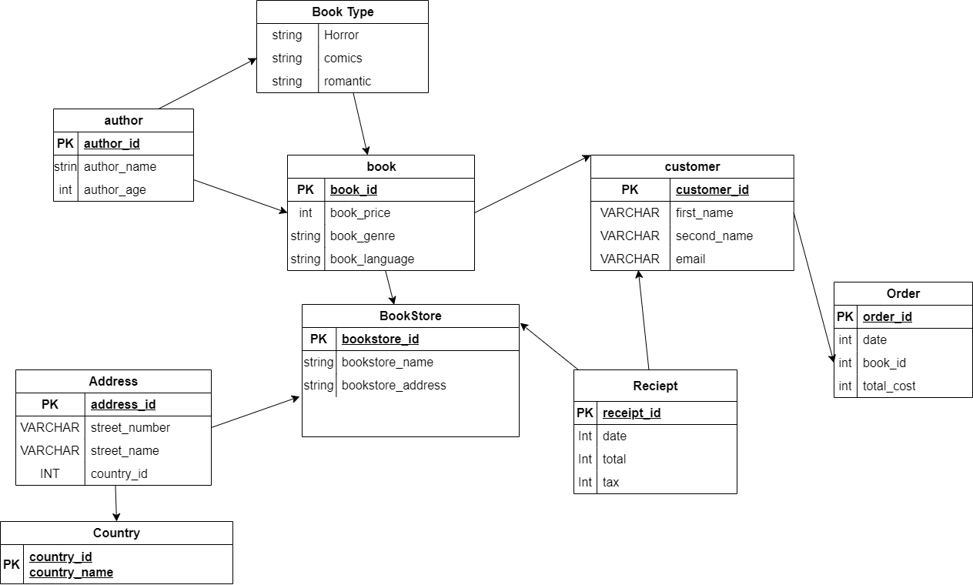

**Brief Explanation:**

First of all the bookstore acts as the main hub and has a country and address related to it, when it comes to the book we have one author and multiple books for each author and additionally book type then we have a customer or also our reader who places a an order and attributes has date,book_id and total cost since the customer receives the receipt we have it linked to the customer

.